**-API Scavenger Hunt-**

**-Assignment by Shounak Kulkarni (CUID – C56298850)-**

[**https://github.com/ShounaKulkarni/api-scavenger-hunt**](https://github.com/ShounaKulkarni/api-scavenger-hunt)

Task1: Solution.

1. current weather for London, United Kingdom –

**Code & output screenshot –**

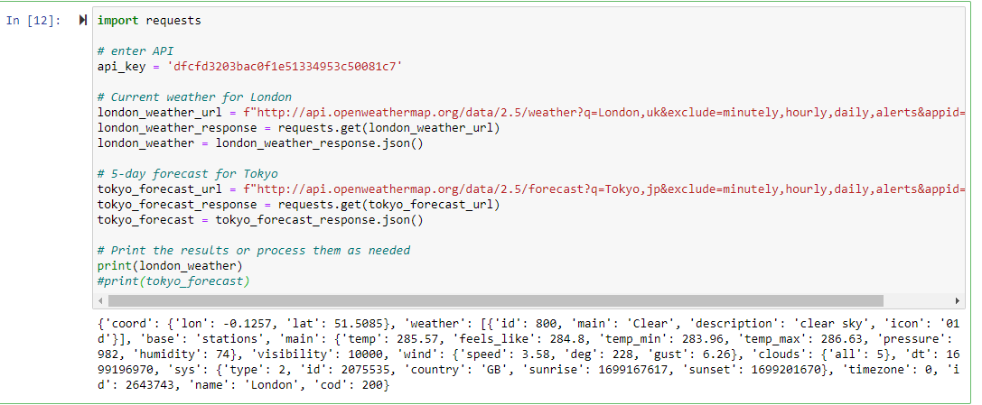

1. 5-day forecast for Tokyo, Japan –

**Code & output screenshot –**

It is not possible to display 5 day data all within a single screenshot. However, I have compiled the entire output into an HTML file titled **task1.html** below. The complete output is also accessible through a Jupyter Notebook file on GitHub. The link to this repository is provided on the first page of this document.



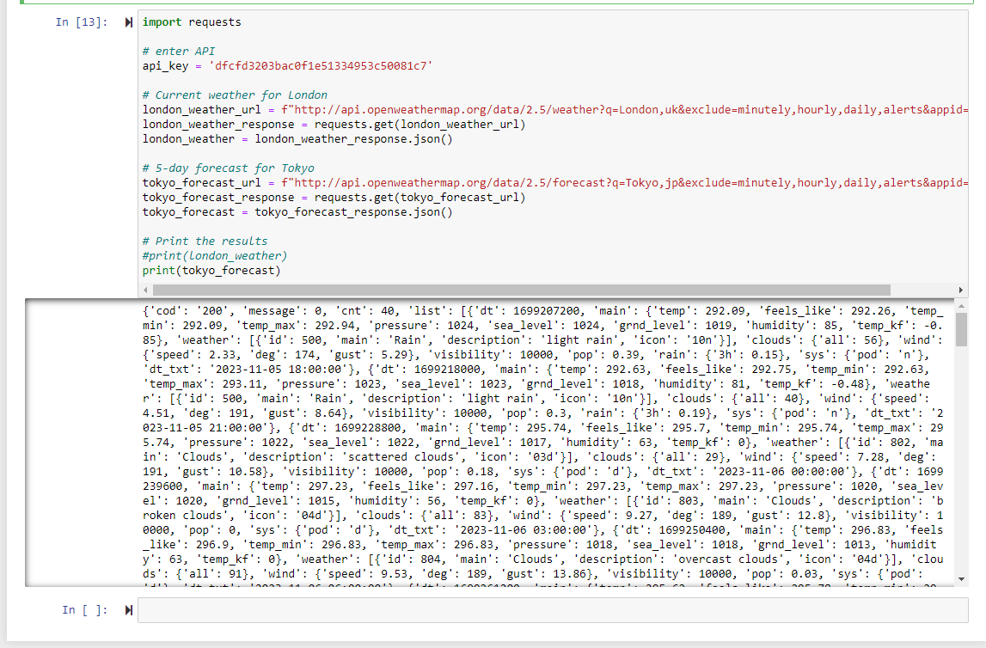

**\*\*\*Reflection of task 1**:

After completing the tasks, reflect on the following:

**Ease of Use**: How easy was it to sign up for the API key and make the API calls?

**Capabilities**: What kind of data can you get from the API, and how detailed is it?

**Potential Applications**: What are some real-world applications for this weather data?

Task2: Solution –

1. map centered on New York City, USA -

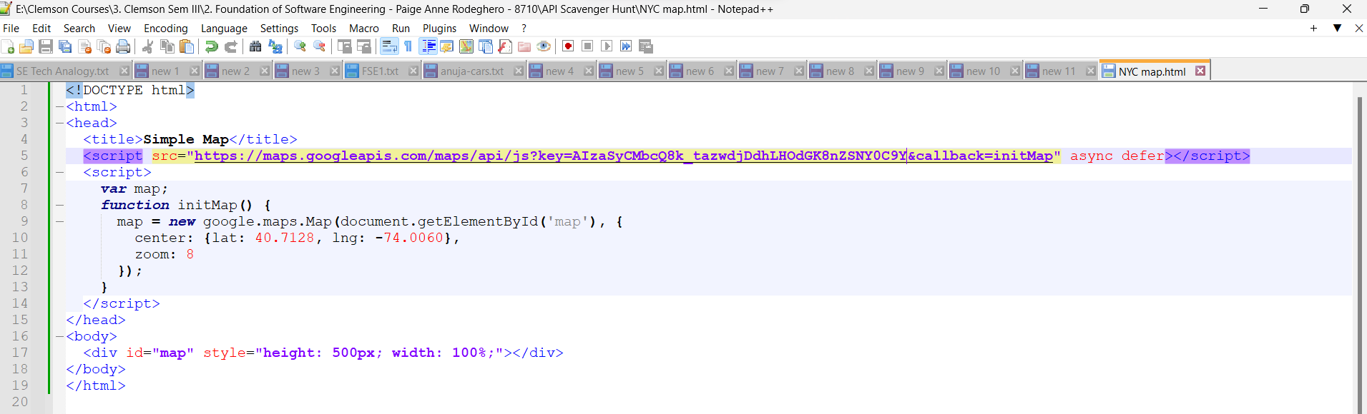



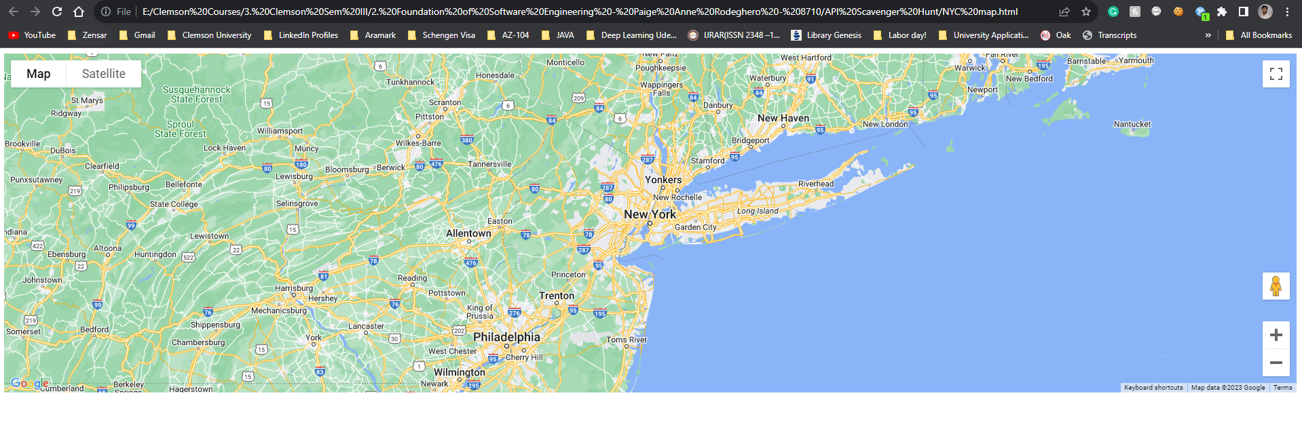

1. shortest route by car between San Francisco, USA, and Los Angeles, USA –

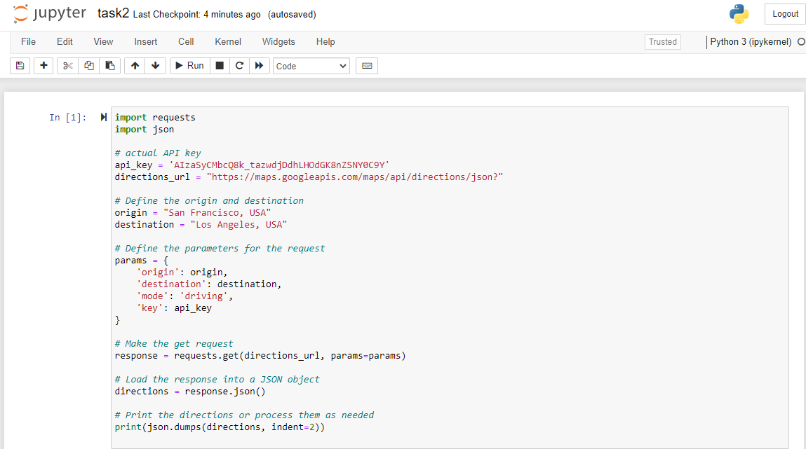

OUTPUT – However, I have compiled the entire output into an HTML file titled **task2.html** below. The complete output is also accessible through a Jupyter Notebook file on GitHub. The link to this repository is provided on the first page of this document.



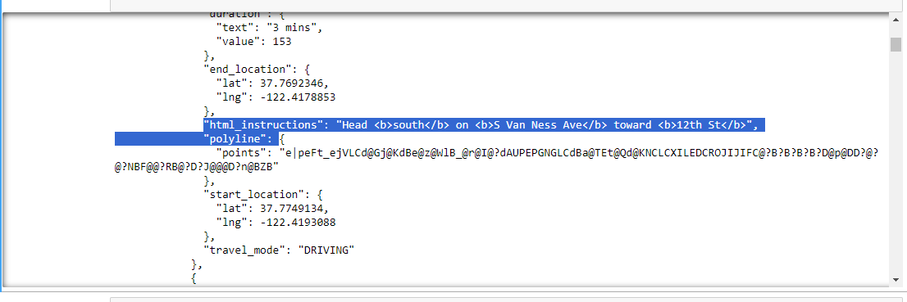

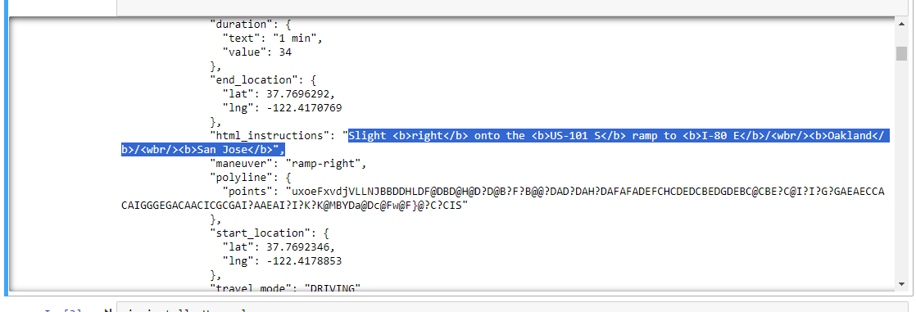

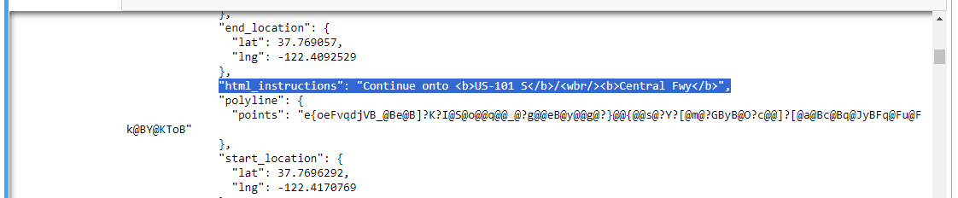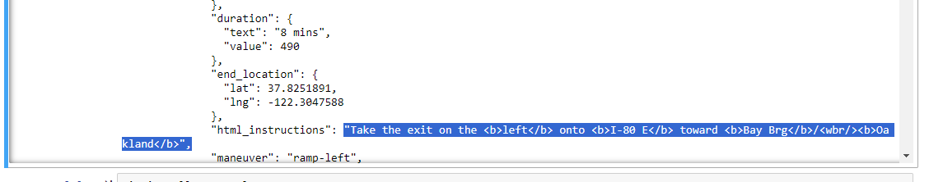

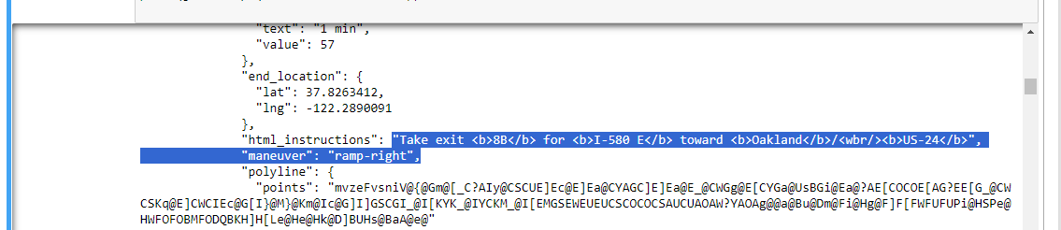

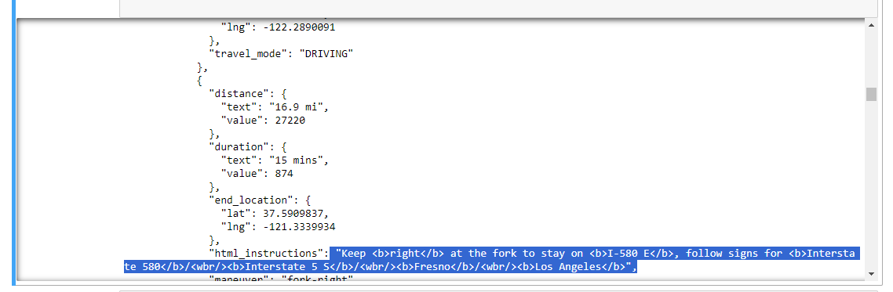

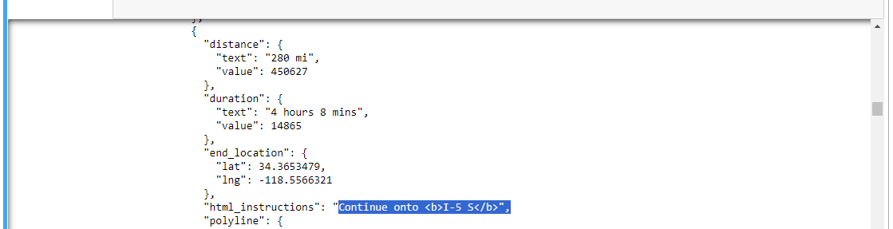

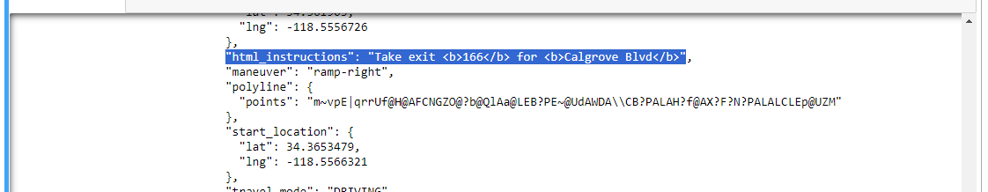



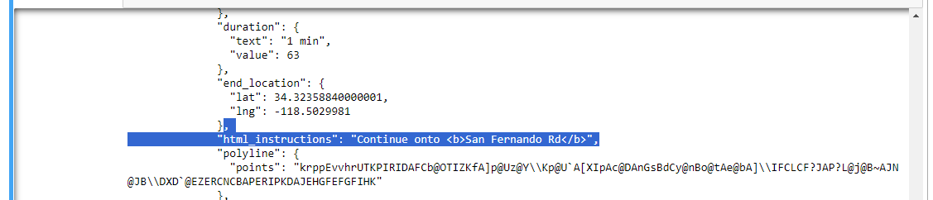

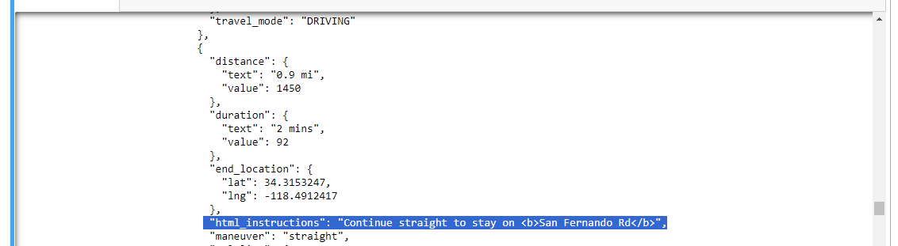



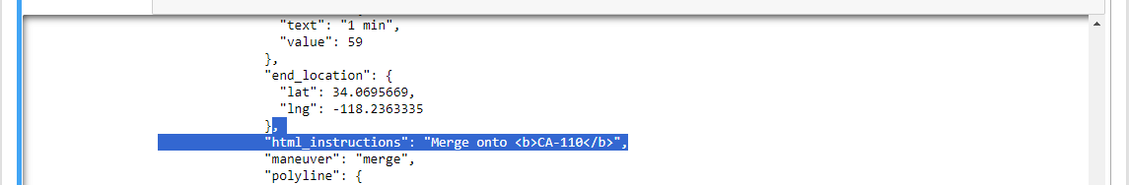

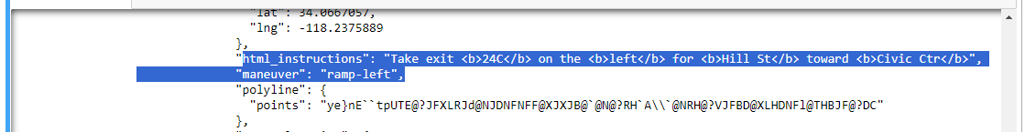





**\*\*\*\*\*\*Reflection of task 2**:

Reflect on the following after completing the tasks:

Ease of Use: How straightforward was it to get the API key and use the Google Maps APIs?

Capabilities: What features and data does the Google Maps API provide?

Potential Applications: Consider how the features you used could be applied in real-world scenarios.

Task3: Solution –

Code snippet –

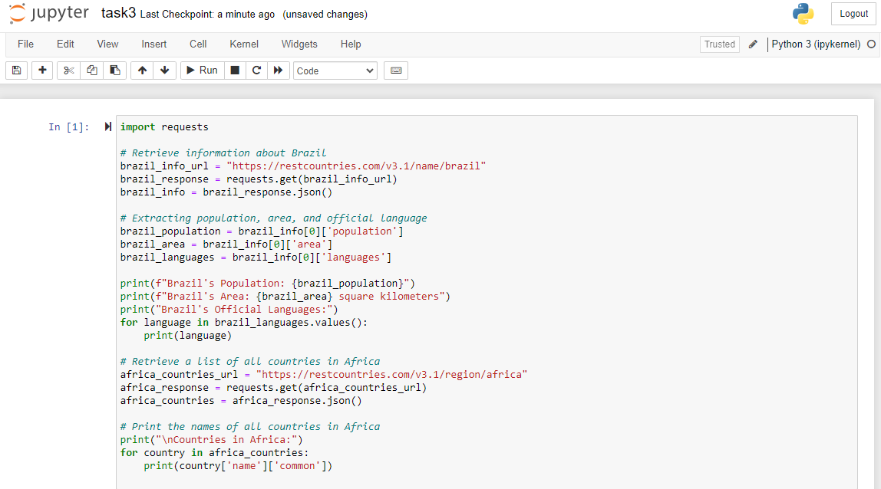

Output Screenshot –

1. information about Brazil, including its population, area, and official language -



1. list of all countries in Africa-

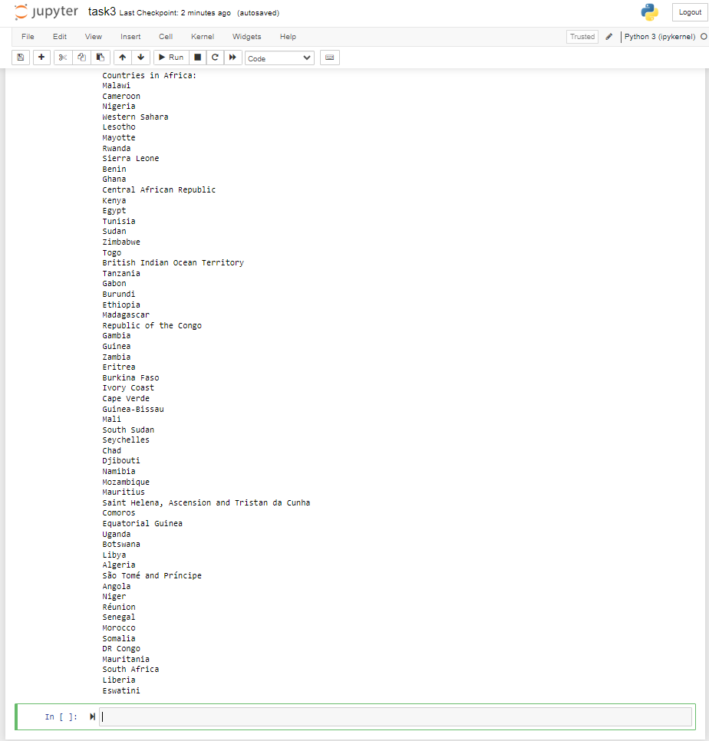

****Reflection of task 3: After completing the tasks, reflect on the following:

Ease of Use: Was the REST Countries API intuitive to use without the need for an API key?

Capabilities: What kind of data can you access about countries, and how might it be useful?

Potential Applications: Consider how you might use the data retrieved in a real-world application.

Task4: Solution –

Source code –

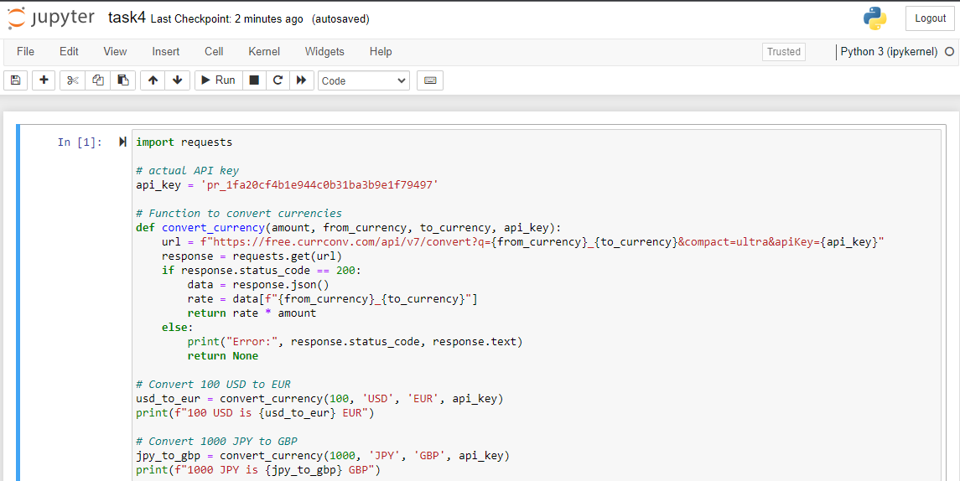

OUTPUT –

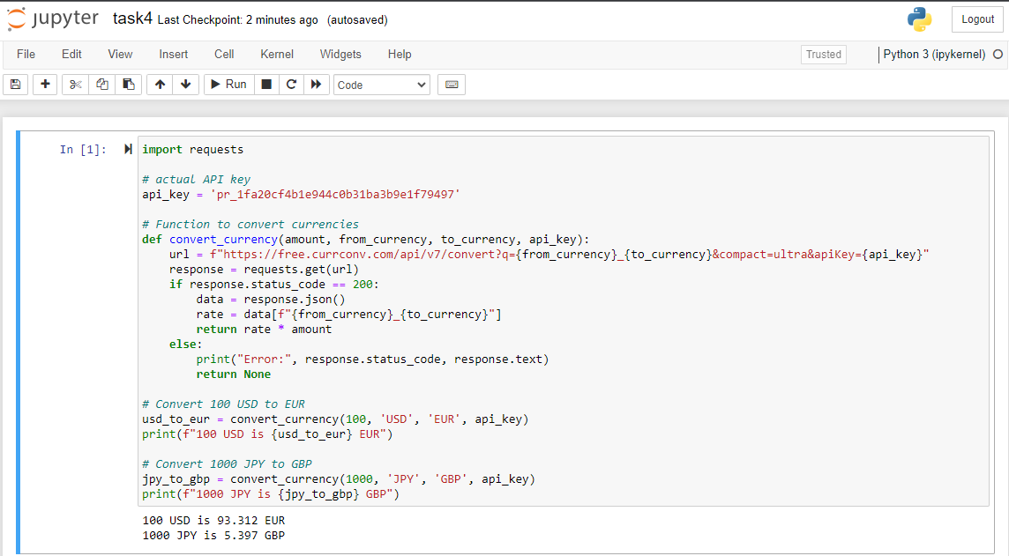

*****Reflection of task 4:

After completing the tasks, reflect on the following points:

Ease of Use: How straightforward was the API documentation? Were the API endpoints well explained? Did you find it easy to integrate the API into your application?

Capabilities: What features does the API offer? Does it meet your needs or the needs of a potential application?

Potential Applications: Consider how this API could be used in real-world applications. For example, could it be integrated into an e-commerce platform for real-time currency conversion?